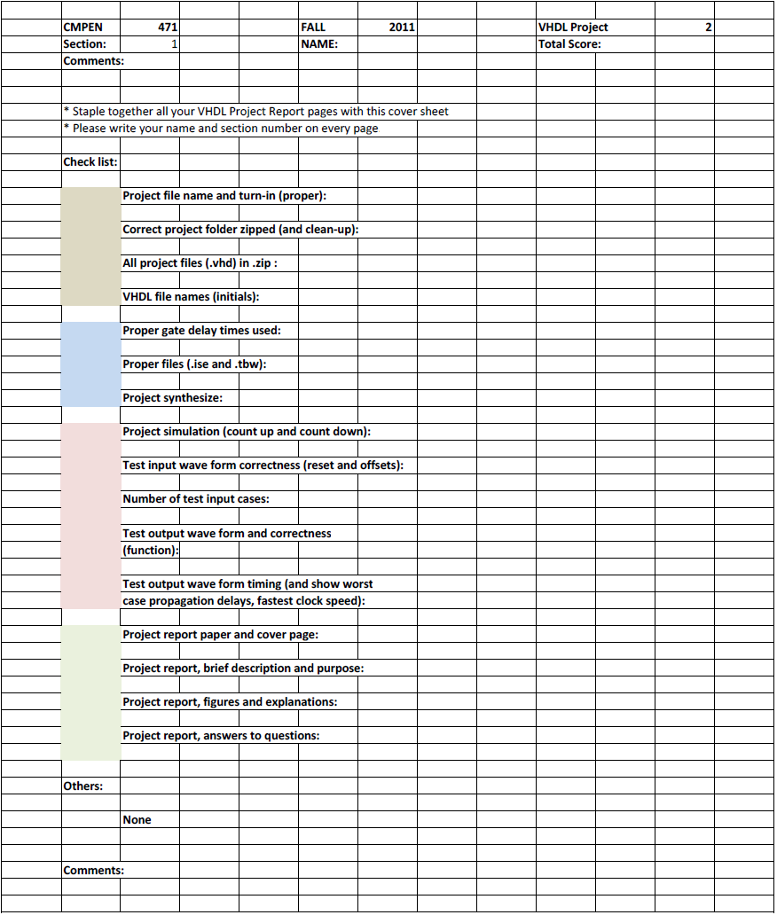
Erik Arfvidson
3

Erik Arfvidson
9/13/2012
Lab2
Project Report3

Questions
5. Do simulate the 6 bit PC and be sure that it is working properly. What is the maximum clock speed of your 6 bit PC in MHz, assuming 50% clock duty cycle?

12. When you complete the ROM implementation, do simulate the ROM and be sure that it is working properly. What is the ROM data access time (minimum signal propagation delay time from address signal to data output on the output buffer)? Can you change the address signal at this rate and access all 64 locations correctly, one by one? What is the data access time from 'csb' signal and from 'oeb' signal?

13. 4 to 1 MUX: Implement a 4 to 1 MUX. Do simulate it and be sure that it is working properly. What is the maximum delay through your 4 to 1 MUX?

14. Frequency Divider: Implement the Frequency Divider. You may design your own frequency divider circuit; however, it must be implemented in structural VHDL. Do simulate it and be sure that it is working properly. What is the maximum clock frequency for your frequency divider?
23. Determine the highest speed of operation: how fast can the signal ckm be clocked for your UFM?

Simulations
22. To verify the functioning of the UFM, design the test bench wave form ufm6bit_tbw1.tbw file. Your simulation must show counting up and counting down. Counting increments or decrements are the 6 bit 2's complement number applied to the B(5:0) input. Design the clock signal ckm at 500 MHz.
23. Design the test bench wave form ufm6bit_tbw2.tbw file. Your simulation must show worst case counting up and counting down. And design the clock signal ckm such that the UFM operates at maximum speed. Determine the highest speed of operation: how fast can the signal ckm be clocked
for your UFM?

//NOTES
Project Report materials to submit: In your project 3 folder, create a MS Word file containing the followings: Captured the simulation waveform results for frequency dividers and multiplier (UFM). Type the answers to the questions. Clearly identify the questions by the step numbers in this Instruction. Print your Word file and staple together all pages, with the cover sheet on the top.

Design each VHDL module file containing a single module. Each file must also contain the comments on the top showing your name, your affiliation, date of creation, the description of the VHDL module.

